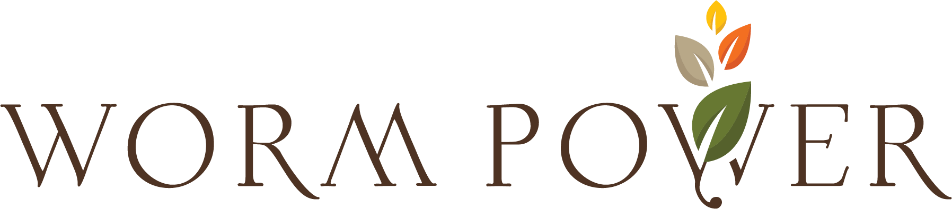

FOR IMMEDIATE RELEASE

ROCHESTER, N.Y., December 18, 2023 Worm Power, the worldwide leader in vermicompost products is pleased to announce the hiring of Linwood Roberts as Region Account Manager for the Southeast US. Linwood has an Associate in Science degree in Row Crop from Mississippi Delta Community College and is based in Florida. Linwood was most recently with Deltag selling specialty and micronutrients to dealers in the southeast and working closely with growers to create demand for their products. Previous to that, Linwood was with the USDA Agricultural Research Service as Farm Manager in Stoneville Mississippi where he conducted research, managed trials and other activities related to best agricultural practices.

Don Cherry CEO of Worm Power said, “We are very excited to be adding additional resources to our team as the company continues to grow in support of our strategic plan. Linwood brings a wealth of experience and knowledge enhancing our ability to support our customer base”.

About Worm Power
Since 2003, Worm Power has been the world leader in organic Vermicompost products, helping growers improve crop yield and plant performance through increased root development and plant nutrient uptake. For more information about Worm Power’s innovative products visit www.wormpower.net.

