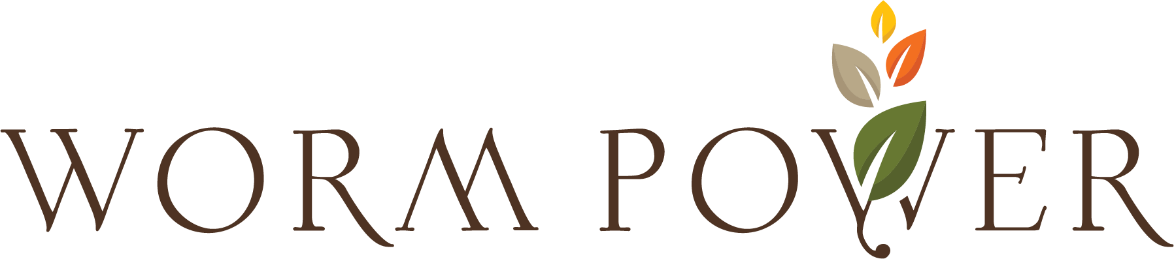

FOR IMMEDIATE RELEASE

ROCHESTER, N.Y., March 4, 2024 Worm Power, the worldwide leader in vermicompost products, is pleased to announce the hiring of Pete Signoretti as National Sales Manager. Pete has a degree in Turf Management with a minor in Horticulture from Clemson University and is based in South Carolina. Pete has extensive experience selling chemical, fertilizer and biologicals products to the golf and turf industries having worked with companies in the industry including Regal, Helena and Intermag North America selling nationally. Pete has many contacts nationally that he will pass on as National Sales Manager to our Region Account Managers to achieve our business goals.

Don Cherry CEO of Worm Power said, “We are very excited to be adding a National Sales Manager to our team as the company continues to grow in support of our strategic plan. Pete brings a wealth of experience and knowledge enhancing our ability to support our customer base”.

About Worm Power
Since 2003, Worm Power has been the world leader in organic Vermicompost products, helping growers improve crop yield and plant performance through increased root development and plant nutrient uptake. For more information about Worm Power’s innovative products visit www.wormpower.net.

